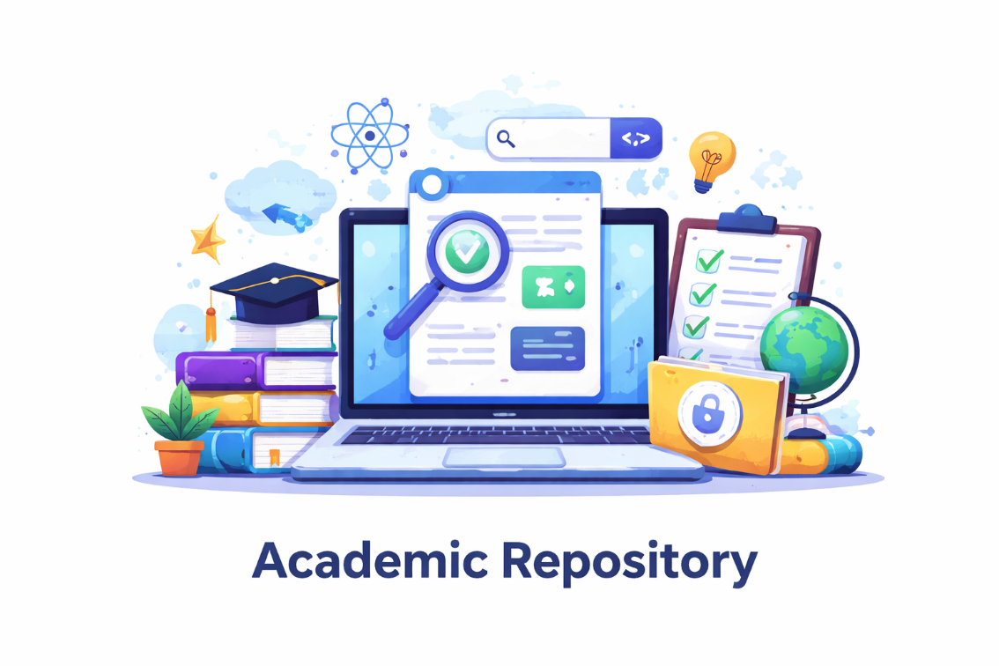

System Summary: Web-Based Academic Repository with Plagiarism Detection

What the System Is
This system is a web application used by schools to manage academic documents.
It allows users to upload, store, and check documents for plagiarism in one place.
It replaces manual work with a faster and organized digital system.

Step-by-Step: How the System Works

Step 1 — User Access & Login
- A user opens the system.
- Guest users can only view limited information.
- Registered users create an account and log in.
- After login, the system gives a token (JWT) to identify the user.
- This token is used to verify the user in every action.

Step 2 — User Roles (Permissions)
The system gives access based on user role:
- Guest → Can only view public documents
- User → Can upload files, check plagiarism, and view their reports
- Admin → Full access (manage users, documents, and reports)

Step 3 — Uploading Documents
- The user uploads a file (PDF, DOCX, or TXT).
- The system checks if the file is valid.
- Text is automatically taken from the file.
- The user adds details (title, author, etc.).
- The system checks:
  - If the title already exists
  - If similarity is too high
  - If too many parts are copied
- If passed, the document is saved in the database.

Step 4 — Plagiarism Detection
The system checks similarity using these steps:
- Text cleaning (lowercase, remove common words)
- TF-IDF (find important words in the document)
- Cosine Similarity (compare documents, result is 0 to 1)
- Paragraph checking (find copied parts)
- n-gram checking (compare phrases)
The results are saved for the user.

Step 5 — Extra Features
- Title Check → Compare titles with other documents
- Internet Check → Compare text with online sources
- AI Check (optional) → Uses AI to detect deeper similarity

Step 6 — Quick Scan
- Users can check a file quickly.
- The file is not saved.
- Results are shown, then the file is deleted.

Step 7 — Viewing Reports
- Only the owner or admin can see the report.
- Others cannot access it.
- The report shows:
  - Similarity score
  - Matched documents
  - Highlighted copied parts

Step 8 — Admin Dashboard
Admins can:
- View total users and documents
- Delete users or files
- View all reports

Step 9 — Logout
- User logs out
- User returns to homepage

Technology Used
- Frontend → HTML, CSS, JavaScript
- Backend → Node.js, Express
- Authentication → JWT, bcrypt
- Database → Supabase (PostgreSQL)
- Plagiarism Detection → TF-IDF + Cosine Similarity
- Optional AI → OpenAI API

